Deep Learning

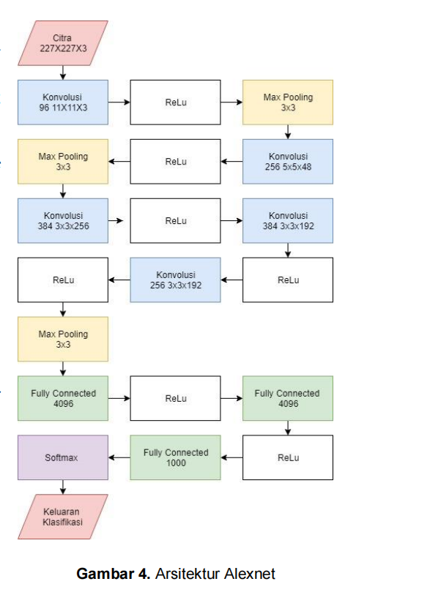

<https://www.kaggle.com/code/rondiyanto/cnn-8januaru2022/edit/run/84792197>

model = Sequential()

model.add(Conv2D(128, (3, 3), padding='same', input_shape=input_shape))

model.add(Activation('relu'))

model.add(Conv2D(32, (3, 3)))

model.add(Activation('relu'))

model.add(MaxPooling2D(pool_size=(2, 2)))

model.add(Dropout(0.25))

model.add(Conv2D(64, (3, 3), padding='same'))

model.add(Activation('relu'))

model.add(Conv2D(64, (3, 3)))

model.add(Activation('relu'))

model.add(MaxPooling2D(pool_size=(2, 2)))

model.add(Dropout(0.25))

model.add(Flatten())

model.add(Dense(512))

model.add(Activation('relu'))

model.add(Dropout(0.5))

model.add(Dense(num_class))

model.add(Activation('softmax'))

# Compile the model

print('Compiling Model.......')

model.compile(optimizer='adam',

loss='categorical_crossentropy',

metrics=['accuracy'])

model.summary()

Model: "sequential"

_________________________________________________________________

Layer (type) Output Shape Param #

=================================================================

conv2d (Conv2D) (None, 150, 150, 128) 3584

_________________________________________________________________

activation (Activation) (None, 150, 150, 128) 0

_________________________________________________________________

conv2d_1 (Conv2D) (None, 148, 148, 32) 36896

_________________________________________________________________

activation_1 (Activation) (None, 148, 148, 32) 0

_________________________________________________________________

max_pooling2d (MaxPooling2D) (None, 74, 74, 32) 0

_________________________________________________________________

dropout (Dropout) (None, 74, 74, 32) 0

_________________________________________________________________

conv2d_2 (Conv2D) (None, 74, 74, 64) 18496

_________________________________________________________________

activation_2 (Activation) (None, 74, 74, 64) 0

_________________________________________________________________

conv2d_3 (Conv2D) (None, 72, 72, 64) 36928

_________________________________________________________________

activation_3 (Activation) (None, 72, 72, 64) 0

_________________________________________________________________

max_pooling2d_1 (MaxPooling2 (None, 36, 36, 64) 0

_________________________________________________________________

dropout_1 (Dropout) (None, 36, 36, 64) 0

_________________________________________________________________

flatten (Flatten) (None, 82944) 0

_________________________________________________________________

dense (Dense) (None, 512) 42467840

_________________________________________________________________

activation_4 (Activation) (None, 512) 0

_________________________________________________________________

dropout_2 (Dropout) (None, 512) 0

_________________________________________________________________

dense_1 (Dense) (None, 5) 2565

_________________________________________________________________

activation_5 (Activation) (None, 5) 0

=================================================================

Total params: 42,566,309

Trainable params: 42,566,309

Non-trainable params: 0

## contoh progam

### klasifikasi-gambar-bunga

<https://github.com/yusufsugiono/klasifikasi-gambar-bunga>

<https://www.kaggle.com/rondiyanto/klasifikasi-gambar-bunga-main/edit>

### simple code

1. <https://machinelearning.mipa.ugm.ac.id/2018/09/30/klasifikasi-gambar-sederhana-menggunakan-convolutional-neural-network/>
2. <https://github.com/venkateshtata/cnn_medium./blob/master/cnn.py>
3. asa

### dog vs cat

<https://www.kaggle.com/george267/dogs-vs-cats-cnn/notebook>

https://becominghuman.ai/building-an-image-classifier-using-deep-learning-in-python-totally-from-a-beginners-perspective-be8dbaf22dd8

### reza

1. <https://www.kaggle.com/rondiyanto/deep-learning-deteksi-motif-batik-tensorflow-v5>

image-clasifier-tf-keras <https://github.com/afif2100/image-clasifier-tf-keras>

Google stock price prediction – RNN <https://www.kaggle.com/ptheru/google-stock-price-prediction-rnn>

coursera-deep-learning-specialization <https://github.com/amanchadha/coursera-deep-learning-specialization>

[back to home](../MAP%20-%20ARTIFICIAL%20INTELEGENT%20BY%20RONDI.docx)